**Redesigned RS PO Viewer 5/7/2020**

I have redesigned the displaying of Rootstock POs on the Opportunity and Product pages. I think they should now have a higher level of accuracy. I also created an option to link to the Rootstock PO from the opportunity or product. In addition, I have removed from the view PO lines that have a quantity of zero.

In order to solve some of the problems we were having I created a new field on the RS PO Line, which is designed to allow us to match the PO’s to the correct product and opportunity. It is automatically populated on PO line creation or change to the project on the PO Line. But, in the situations where the PO line can not be updated, it allows for a manual update.

In order to access this new field from the PO line click on the Details button.

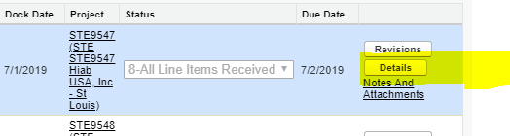

Click on the STE Custom Tab and enter the correct Project number in the STEProject textbox. 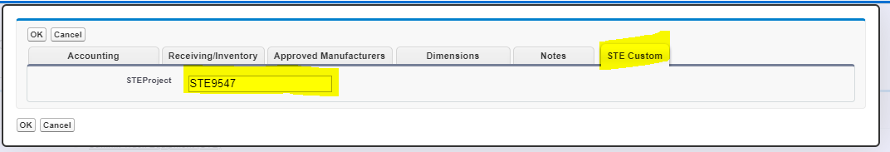

Note: If possible we should change the Project number on the Po Line. This done by selecting the Accounting Tab and entering the value in the project textbox. (This will automatically update the STEProject textbox on the STE Custom Tab). There are cases where you will not be able to adjust the project on the PO Line, in those cases update the STE project textbox as described above.

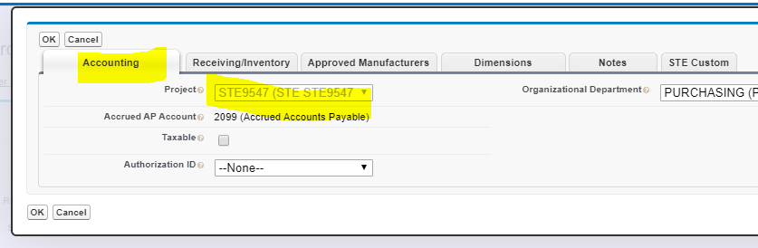

The above is important because now PO’s are selected base on the STE Project field. If it is not correct the system will not pull the correct PO’s.

The system also assumes that New Chassis and Used Units will have as there project number the Last Six of the VIN and that Service bodies with have a project number “STE*****” (Lubeskids – “LS*****”, Lube Trailers – “LT*****”). It also assumes that for New Chassis the Last Six of the Vin will be in the Item field on the PO line for the selected product. This is also important, because the system will use this field to find the Chassis PO.

